|  |
| --- |
|  |



**11 January 2013** **The Weekly Bulletin of Rotary Club of Kathmandu Mid-Town** **Bc-11.1/012-13**

**District : 3292 Web: www.rotarymidtown.org.np Club Id : 26776**

**JANUARY IS ROTARY AWARENESS MONTH**

It’s a time to learn more about our organization, and a time to focus on our public image. Raising awareness of Rotary is an important part of the RI Strategic Plan: The more Rotary is known for its good work, the more good work Rotary will be able to do.

Friday, 4 January:

Dr Rabindra Shrestha, Mid-Towner, took the forum as the in-house speaker

and provided an interesting account of Mt Kailash, meditating Buddha,

Sriyantra – 9 triangles, 4 from top and 5 from bottom, at middle point 'bindu'.

He symbolizes Nepal as 'cultural fridge' and symbol of unity in diversity of

Hindu culture.

# Weekly Meetings and Programs :

|  |  |  |
| --- | --- | --- |
| Date | Program/Speaker | Program/Topics of Presentation |
| 11 Jan 2013 | HE Asko Luukkainen,  Ambassador of Finland | Nepal-Finland Relations |
| 18 Jan 2013 | ?? |  |

Friday, 11 January:

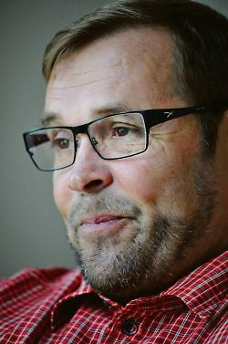

Asko Luukkainen, Ambassador of Finland to Nepal, will be our Guest Speaker for the day.

HE Asko will be talking on Nepal-Finland relations. He is the first resident Ambassador of

Finland to Nepal. Before coming to Kathmandu in September 2011 he was working as

Chargé d' Affaires in Namibia. He has experiences of dealing in Nepal as he had worked

earlier as Chargé d' Affaires in the Finnish Embassy, Kathmandu from 2000 to 2004.

**Mt Kailash:**

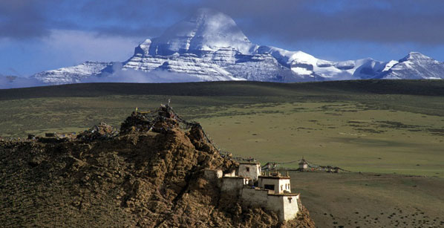

Mt. Kailash, Asia's most sacred mountain, is located in a high and isolated enclave of West Tibet. Mt Kailash is their soul-mountain. To Buddhist believers, it is the abode of Demchok, the wrathful manifestation of Buddha Sakyamuni. For Hindus, Kailash is at the center of the universe. Four major rivers of Tibet, India and Nepal have their sources near Kailash.

Above all the sacred mountains of the world the fame of Kailas has spread and inspired human beings since times immemorial. There is no other mountain comparable to Kailas, because it forms the hub of the two most important ancient civilizations of the world, whose traditions remained intact for thousands of years: India and China. To Hindus and Buddhists alike, Kailas is the centre of the universe. Thus to Hindus Kailas is the seat of Shiva, while to Buddhists it represents a gigantic mandala of Dhyani-Buddhas and Bodhisattvas, as described in the famous Demchog (Chakrasamvara) Tantra, the ‘Mandala of Highest bliss’.

Mount Kailash, at 6714m, is not the highest of the mountains in the region, but with its hulking shape, like the handle of a millstone according to Tibetans, and its year-round snowcapped peak, it stands apart from the pack. Its four sheer walls match the cardinal points of the compass, and its southern face is famously marked by a long vertical cleft punctuated halfway down by a horizontal line of rock strata. This scarring resembles a swastika, a Buddhist symbol of spiritual strength, and is a feature that has contributed to Kailash’s mythical status. The mountain is known in Tibetan as Kang Rinpoche, or ‘Precious Jewel of Snow’.

Kailas forms the spire of the ‘Roof of the World’ and radiating from it, like spokes from the hub of a wheel, a number of mighty rivers take their course towards the east, the west, the north-west, and the south. These rivers are the Brahmaputra (Yarlung Tsangpo), the Indus, the Sutlej, and the Karnali (feeds into the Ganges). All these rivers have their source in the Kailas-Manasarovar region, which forms the highest tier of the Tibetan plateau. This is especially apparent in the case of the Indus and the Brahmaputra, which, like two gigantic arms emerging from the Kailas-Manasarovar region, embrace the entirety of the Himalayas and the whole of the Indian subcontinent, the Indus flowing into the Arabian Sea in the west, the Brahmaputra into the Bay of Bengal in the east.

At the southern foot of Kailas there are two sacred lakes, Manasarovar and Rakastal, of which the former is shaped like the sun and represents the forces of light, while the other is curved like the crescent moon and represents the hidden forces of the night. ‘Manas’ means mind or consciousness: the seat of the forces of cognition, of light, of enlightenment. ‘Rakas’ means demon, so Rakastal means ‘Lake of the Demons’.

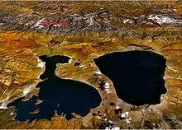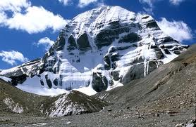

*Source:  Mountains of Travel Photos*

**Bishnumati River Re-habilitation Project, 'Mission Impossible':**

Sustainable awareness campaign covering the River Bishnumati corridor, through an effective coordinated effort of all the genuinely interested parties, starting from its source, at Shivapuri to its confluence with the River Bagmati, a distance of 18 km, at "Teku Doban.

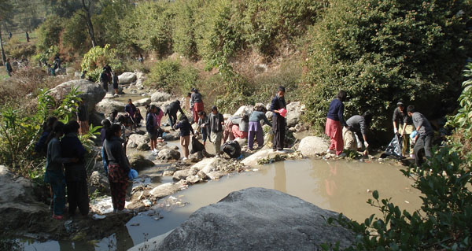 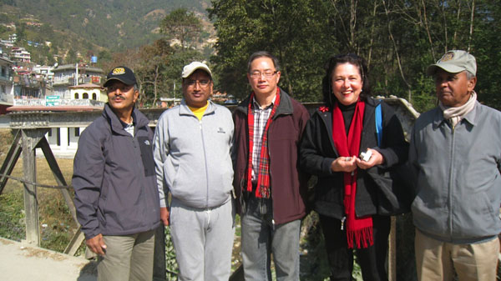

The start up program was held on 22 Dec 2012 with all the stakeholders of the community of Budhanilkantha Bridge area (Sector 1), to show their concern about the gravity of the problem and to make the campaign a success.

This will be followed by targeting the community at the next bridge location, during every last Saturday of the month respectively, till the entire River Bishnumati corridor of 10 sectors has been covered.

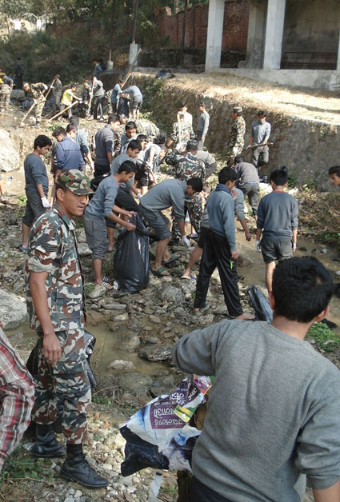 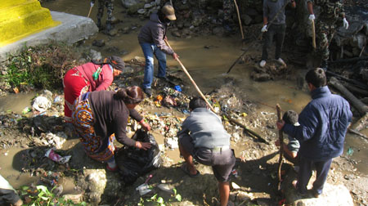Budhanilkanth School students, army unit, and local community members

joining hands in support of cleaning campaign.

When we see the needs of others as more important than our own needs — when we focus

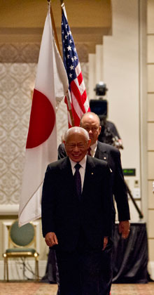

our energies on a shared goal that is for the good of all — this changes everything. It changes

our perceptions. It changes how we relate to the world. It changes our priorities in a fundamental way. And it changes how we understand the idea of peace.

**RI President Sakuji Tanaka**

**Committee Chairpersons' Column:**

Public Relations Committee report presented at the Club Assembly on 21 Dec 2012:

Programme activities in the year to date have been:

Media events to promote club projects and activities;

Particular emphasis on the Italian Bolzano/Bozen fire fighting equipment project and handover 19 August 2012 ,which received wide media coverage;

Media coverage on Mid-Town’s very special Charter Night Dinner on 19 November 2012 in the presence of Mr Sakuji Tanaka, global President of Rotary International. A banner proclaimed “Home Club of the District Governor”. Three new members were inducted: HE Peter Bodde the United States Ambassador (returning to Nepal after 12 years), HE Franke Meyke the new German Ambassador, and Catherine Jenson CEO of Sheer Memorial Hospital Banepa;

All Mid Town members have been provided with two each Rotary Emblem stickers for their vehicles to raise the profile of Rotary. Many thanks to Rtn Mani for helping the PR Committee design and produce 100 stickers for this purpose.

Plan for the next part of the Rotary year: Major overhaul of club website, with an initial needs analysis of what should be done and investigation of Facebook page possibilities

*courtesy:* *Rtn Lisa Chyoegal, Chairperson, Public Relations Committee*

**Past Presidents' Column:**

**?????**

On Lighter Side :

Click here ⇩



A Thought For The Day:

**When old words die out on the tongue, new melodies break forth from the heart;**

**and where the old tracks are lost,**

**new country is revealed with its wonders!**

- Rabindranath Tagore

*courtesy:* Rtn Dr Isabella C Bassingana Khadka

Great Quotes:

***When flood comes, fish eat ants and when flood recedes, ants eat fish.***

***Only time matters.***

***Just hold on, God gives opportunity to everyone!***

Puzzle:

If 1 = 5, 2 = 25, 3 = 125, 4 = 625, 5 = ??

NB: Send any informations/photos that may be of interest to the Club or Rotarians in general to

BC Editor: RR Shrestha email: rryesrr@gmail.com

## 11 Jan 2013 The Weekly Bulletin of Rotary Club of Kathmandu Mid-Town bc-11.1/012-13